

**Faculty of engineering - Shoubra**

**Benha University**

**Research Article**

in fulfillment of the requirements of

|  |  |
| --- | --- |
| **Department** | **Engineering mathematics and physics** |
| **Division** | **------------** |
| **Academic Year** | **2019-2020 Preparatory** |
| **Course name** | **Computer** |
| **Course code** | **ECE001** |

**Title: -**

**……Build a website on recent computer engineering topics…**

**Programming language (python)**

By:

|  |  |  |  |
| --- | --- | --- | --- |
|  | Name | Edu mail | B.N |
| 1 | Mahmoud Ahmed Abdelzaher Ahmed | Mahmoud195926@feng.bu.edu.eg | 829 |

**Approved by:**

|  |  |
| --- | --- |
| Examiners committee | Signature |
| Dr.Ahmed Bayoumi |  |
| Dr.Shady Elmashad |  |
| Dr. Abdelhamid Attaby |  |

**Introduction**

**Definition of python**

I will discuss one from programming language it's python Python is a high-level, general-purpose and localized programming language. Created by Guido van Rossum and first released in 1991 the Python design philosophy emphasizes the ability to read code with its notable use of important white spaces. Its language structures and object-oriented approach aim to help programmers write clear logical code for small and large projects.

**Some uses of python**

1-Machine learning and artificial intelligence Machine learning and artificial intelligence is about city conversations as it gives the most promising jobs for the future.

2-Game development Python is also used in the development of interactive games. There are libraries like PySoy which is a 3D game engine that supports Python 3 and PyGame that provides functionality and a library for developing games.

3-Data science and data visualization The data is money if you know how to extract relevant information that can help you assume calculated risks and increase profits. You study your data, perform operations and extract the required information

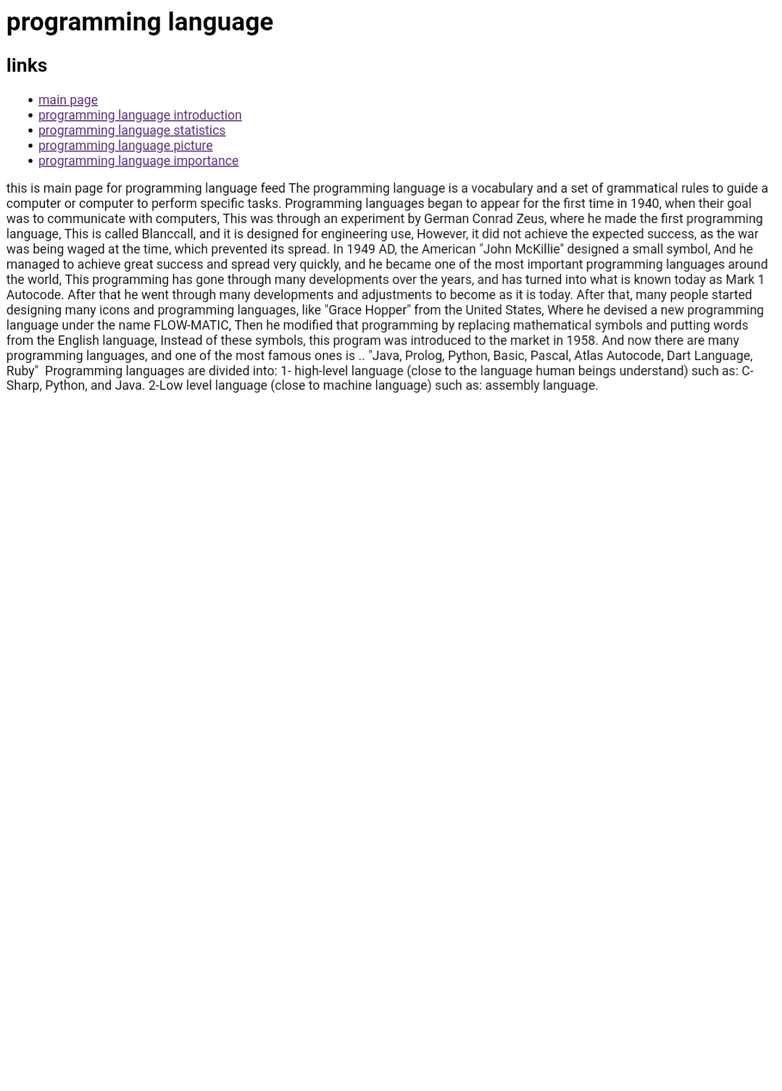**Screenshot**

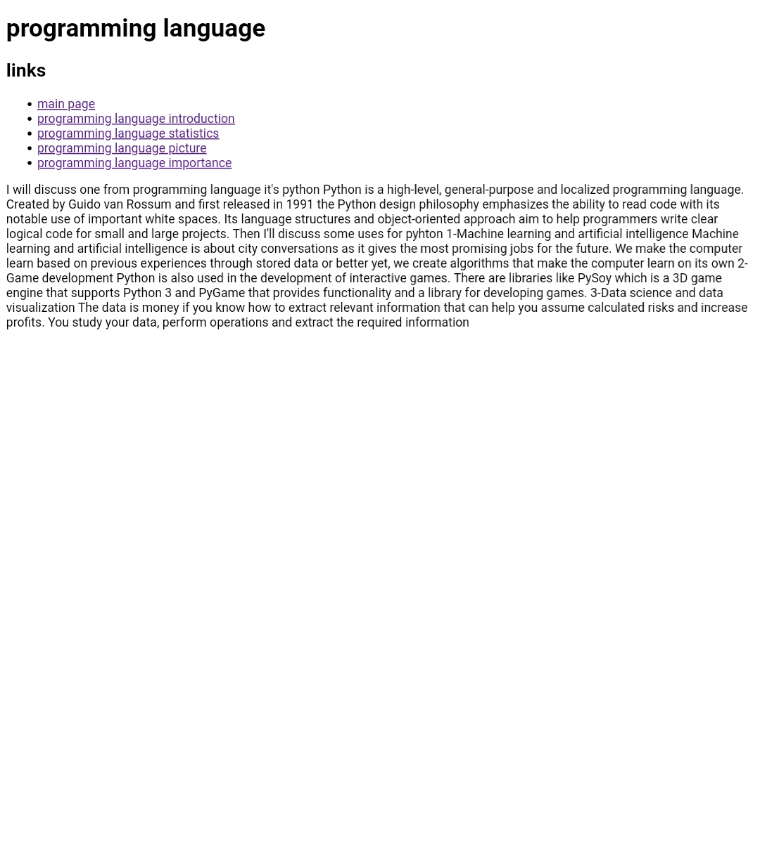

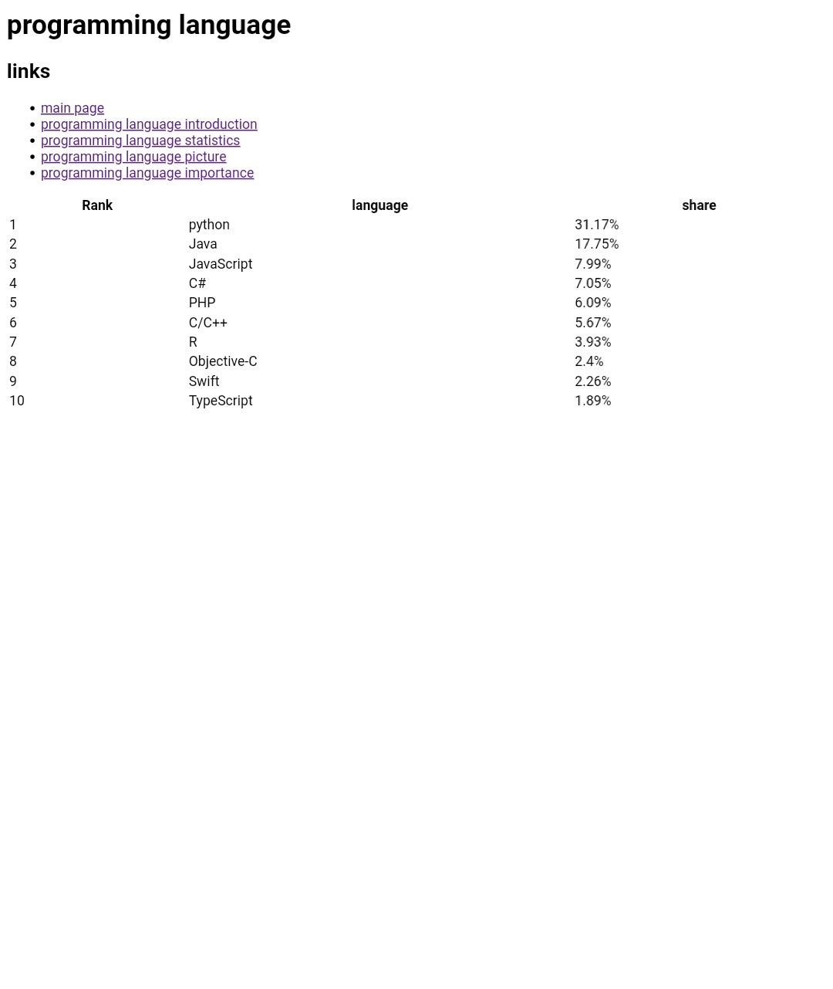

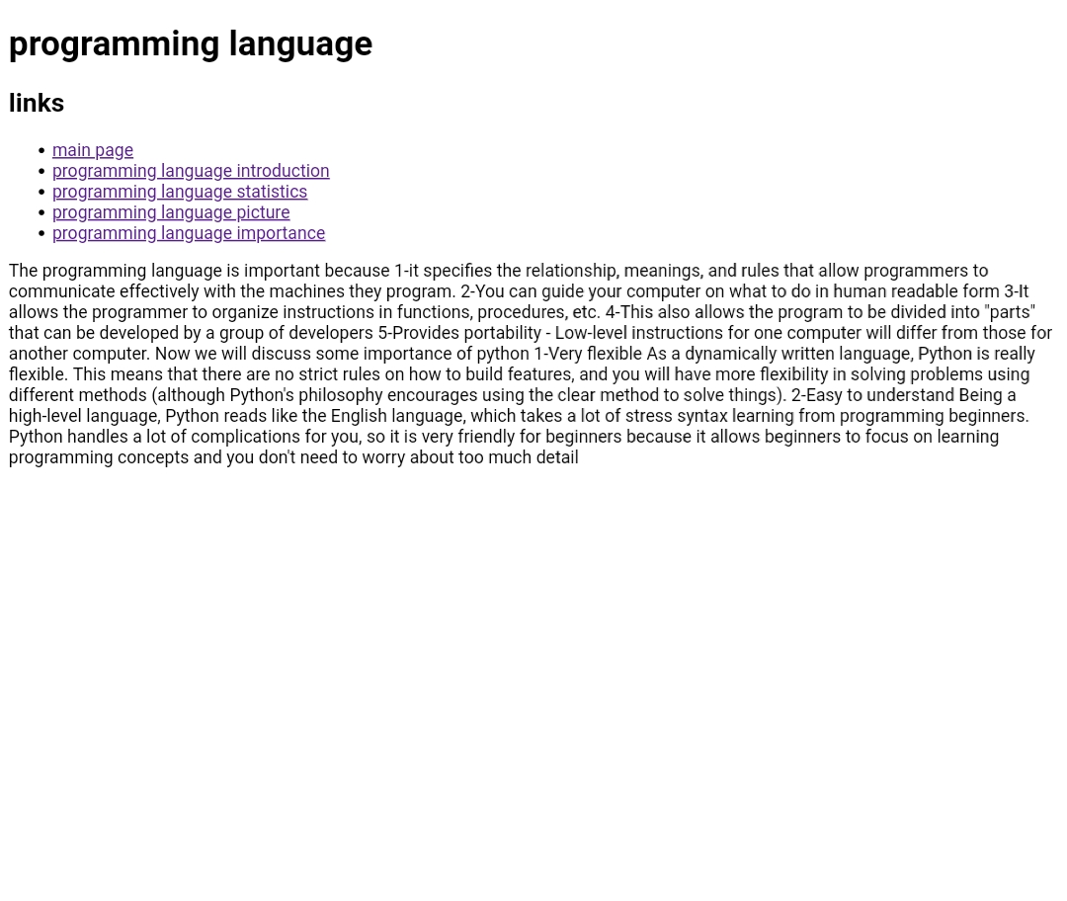

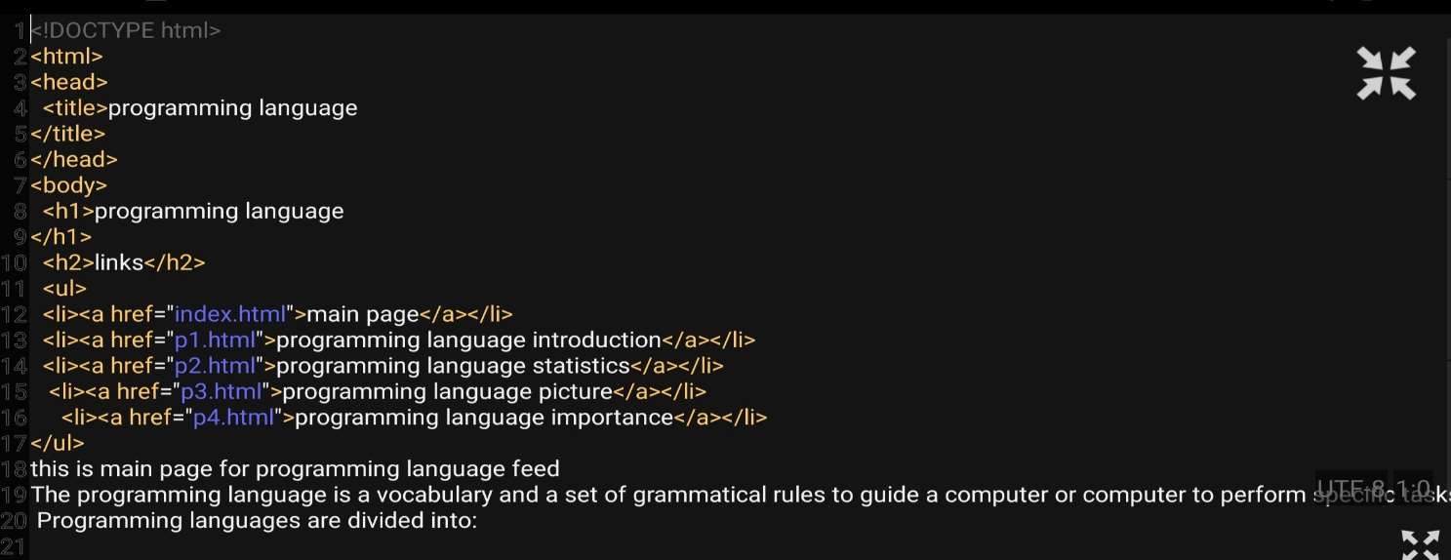**Source code**



